

**FUNDAMENTALS OF DATATABASE MANAGEMENT SYSTEM**

CIS 8040 TEAM PROJECT FINAL REPORT

**PET-ATL OLINE STORE**

ONLINE STORE APPLICATION

**TEAM MEMBERS:**

RUHANI CHAWLA

SANCHIT BOGRA

JASDEV SINGH SACHDEVA

SHUBHAM MODI

**USER REQUIREMENT ANALYSIS**:

The overall scope of the project is to store, manage the online products offered by the PetATL website using Adobe Cold fusion Server and Oracle SQL Developer. Cold fusion is used for creating the web server and links it to the sql developer, which is used for implementation of the database. The business rules are explained below :

1. Customers should be able to use the PetATL website from any Web browser supporting HTML 3.2 (or later).
2. Each customer can have :
   * Username - Every customer has an unique identification number
   * Name – First name of the Customer
   * PhoneNum  - Every customer provides a single contact number
   * Street - street details of the address
   * City – City name
   * State – State name
   * Country – country name
   * Zip_Code  - mention the zipcode
   * Email – the email address of the customer is used as login to website
   * Password - Every customer can set a password to login to website
3. Customers new to the site should be able to signup to place an order or view the list of products. Customers will be differentiated by unique user identifiers.
4. Customers should be able to view and purchase the list of specified items available through the site.
5. The product have the following information stored in the database:
   * ProdID – It is the unique identification number (primary key) to differentiate every product
   * Description – it provides the basic description of the product
   * Name - Each product has a name or title
   * Dimension – it provides the length, breadth  and height of the product packet
   * Image - It displays an image of the product
   * Weight - Product weight is displayed.
   * Stock – It displays the stock of each product in inventory
   * Vendor – Each product has an manufacturer.
   * Cost - The selling price of the product
   * Discount – Each product has discount percentage associated with it.
6. Each product has product description.
7. The order can have :
   * OrderID – it refers to unique identification number of the order
8. The order can have one or more products.
9. An order includes the quantity and cost of each product purchased
10. A customer can have multiple orders for different product
11. The system shall provide shopping cart during online purchase. The cart can have zero or many products.
12. The cart has a unique identifier and includes quantity of the product which customer selects.
13. The cost of every product is included in the cart.
14. The customer has to add the products first to the cart before buying the product.
15. Customers should be able to choose items and add them to their shopping carts for purchasing the items.
16. Customers should be able to modify the quantities of items in and/or delete items from their shopping carts before checkout.
17. Customers should be able to view the status of items they have ordered.
18. A vendor update the quantity of every products.
19. A vendor has a unique identifier and password.
20. The vendor has a name of company being used products are shown on the website
21. All ordered items should be shipped to the user following purchase details; shipping is out of the scope of the project.
22. The order is complete when the user enters all the billing information along with the shipping address details.
23. When the order is processing, it should go through the processing which can have the following information:
    * PaymentID – Unique identification number for each Payment made by the customer
    * Payment_Type – payment type such as credit card or debit card
    * Card_Number – Number of the debit/credit card
    * Cvv   -3 digit code behind the card
    * Exp_date – expiry date on the card
    * FName – first name on the card
    * LName – last name on the card
    * Street - street details of the address
    * City – City name where the address is billed
    * State – State name where the address is billed
    * Country – country name where the address is billed
    * Zip_Code  - the zipcode
24. Multiple customers should be able to use the application simultaneously.
25. The performance of the application should not degrade with an increase in the number of units or services offered.
26. The addition and updation of products is out of the scope of the project.

**CONCEPTUAL MODELLING :**

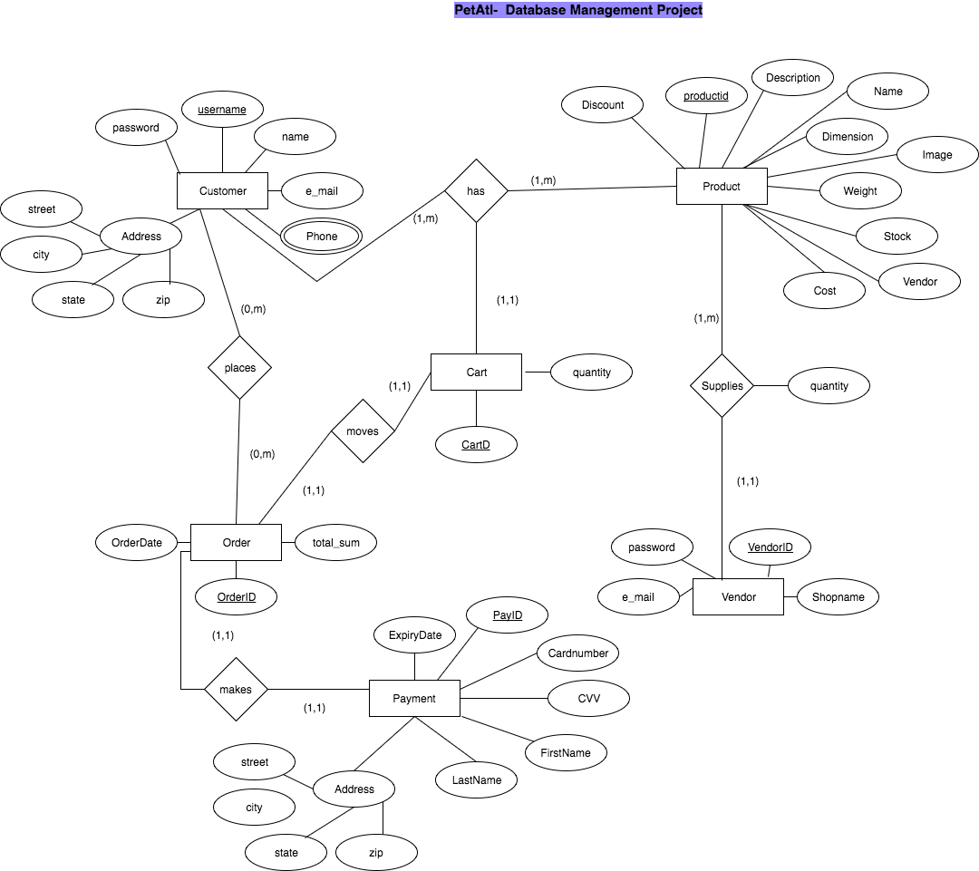

**ER MODEL MAPPING:**

**Table Structure:**

* **Atl_Customer**(Usernamepk,email,name,street,city,state,zip_code, password)
* As phone is a multivalued attribute, it requires a separate table as

**Atl_Cust_phone**(usernamefk, Phone)

* **Atl_Product**(ProdIDPK,Name,Weight,Description,stock,manufacturer,dimension,cost,discount,feature,image)
* **Atl_Cart**(CartIdpk,usernamefk,ProdIDfk quantity)
* **Atl_Order** (OrderIdpk, CartIdfk,Date, Total_sum)
* **Atl_Vendor** (VendorIDpk, ProdIdfk,password, email, Name)
* **Atl_Payment(**PayIdpk, Orderid(fk), card_no,cvv,expiry_date, fname, lname, street,city, city,state,zip_code)
  + - The Order id refers to the order id in the order table.
    - There is one to one relationship between order and payment.
* Relation between order,cart and customer:
  1. **Atl_Order_Details**(OrderIdfk,CartIdfk,cost, quantity)
  2. **OrderCustomer**(OrderId,CustIDFk,date)

**NORMALIZATION :**

* **Candidate Keys :**

1. Atl_customer : username or email
2. Atl_customer_phone : username and phone
3. Atl_Product : ProductId
4. Atl_cart: CartId, CustomerId, ProductId
5. Atl_Order : OrderId
6. Atl_vendor:VendorId
7. Atl_Payment : PaymentId
8. Atl_Order_Details : OrderId,CartId

* **Primary Key**
  1. Atl_customer : username [Choosing username as the primary key]
  2. Atl_customer_phone : username and phone
  3. Atl_Product : ProductId
  4. Atl_cart: CartId, CustomerId, ProductId
  5. Atl_Order : OrderId
  6. Atl_vendor:VendorId,ProductId
  7. Atl_Payment : PaymentId and OrderId
  8. Atl_Order_Details : OrderId,CartId
* **Full Functional Dependencies :**

1. Prj_customer: username🡪 email,name,street,city,state,zip_code, password ; zip🡪city, state
2. Atl_Product : ProductId 🡪 Name, Weight, Description, stock, manufacturer, dimension, cost, discount, feature, image
3. Atl_cart: CartId,username,ProdID 🡪quantity
4. Atl_Order : OrderId🡪 Date, Total_sum
5. Atl_vendor:VendorId🡪password, email; ProductId 🡪Name
6. Atl_Payment :

PaymentId🡪 card_no,cvv,expiry_date, fname, lname, street,city, city,state,zip_code ;

card_no🡪cvv, expiry_date;

zip_code🡪 city, state

1. Atl_Order_Details : OrderId,CartId🡪quantity

* **Normalization**
  1. Atl_customer : The table is already in 1NF and 2NF. We need to convert it to 3NF as there is transitive dependency between :Username🡪email, street, zipcode, password and zip🡪 state,city
     + **Atl_Customer**(Usernamepk,email,name,street, zip_codefk, password)
     + **Atl_Cust_Address**(Zipcode, city,state)
  2. **Atl_Cust_Phone** : the table is already in 1NF, 2NF and 3NF
  3. **Atl_Product** is already in 1NF, 2NF, 3NF. No need for normalization.
  4. **Atl_Cart**: is already in 1NF, 2NF, 3NF. No need for normalization.
  5. **Atl_Order:** is already in 1NF,2NF and 3NF. No need for normalization.
  6. **Atl_Vendor** : is already in 1NF,2NF and 3NF. No need for normalization.
  7. **Atl_Payment** :is already in 1NF, 2NF. Needs to be converted to 3NF.
     + PayIdpk, Orderid(fk)🡪 card_no, fname, lname, street, zip_code
     + Card_no🡪cvv, exp_date
     + zip🡪 state,city
     + Tables are : Atl_Payment (PayIdpk, Orderid(fk), card_nofk, fname, lname, zip_codefk)
     + Atl_card(CardNo, CVV, expiry)
     + Atl_Payment_Address(Zip, city, state)
  8. **Atl_Cust_Prod**: is already in 1NF,2NF and 3NF. No need for normalization.
  9. **Atl_Order_Details** : is already in 1NF,2NF and 3NF. No need for normalization.

**DATABASE IMPLEMENTATION:**

Table Creation Attribute and Script:

1. **ATL_CUSTOMER Table:**

|  |  |  |  |  |
| --- | --- | --- | --- | --- |
| Name | Type | Nullable | Key | Referential Constraint |
| USERNAME | NUMBER(38,0) | No | PRIMARY KEY |  |
| EMAIL | VARCHAR2(50) | No |  |  |
| NAME | VARCHAR2(50) | No |  |  |
| STREET | VARCHAR2(50) | Yes |  |  |
| PASSWORD | VARCHAR2(50) | No |  |  |
| ZIP_CODE | NUMBER(10,0) | No |  | References zipcode in ATL_CUST_ADD |

CREATE TABLE ATL_CUSTOMER

(

USERNAME VARCHAR(20) NOT NULL PRIMARY KEY,

EMAIL VARCHAR(30) NOT NULL,

NAME VARCHAR(30) NOT NULL,

STREET VARCHAR(30),

ZIP_CODE NUMERIC(10),

PASSWORD VARCHAR(20) NOT NULL,

CONSTRAINT customer_fk FOREIGN KEY(ZIP_CODE) REFERENCES ATL_CUST_ADD(ZIP_CODE)

);

1. **ATL_CUST_ADD Table :**

|  |  |  |  |  |
| --- | --- | --- | --- | --- |
| Name | Type | Nullable | Key | Referential Constraint |
| ZIP_CODE | NUMBER(10,0) | No | PRIMARY KEY |  |
| CITY | VARCHAR(20) | Yes |  |  |
| STATE | VARCHAR(20) | Yes |  |  |

CREATE TABLE ATL_CUST_ADD

(

ZIP_CODE NUMERIC(10) PRIMARY KEY,

CITY VARCHAR(20),

STATE VARCHAR(20)

);

1. **ATL_PRODUCT**  **Table:**

|  |  |  |  |  |
| --- | --- | --- | --- | --- |
| Name | Type | Nullable | Key | Referential Constraint |
| PRODID | NUMBER(38,0) | No | PRIMARY KEY |  |
| DESCRIPTION | VARCHAR2(200) | No |  |  |
| NAME | VARCHAR2(100) | No |  |  |
| DIMENSION | VARCHAR2(50) | No |  |  |
| IMAGE | BLOB | YES |  |  |
| WEIGHT | VARCHAR2(50) | No |  |  |
| STOCK | VARCHAR2(50) | No |  |  |
| MANUFACTURER | VARCHAR2(50) | No |  |  |
| COST | NUMBER(6,2) | No |  |  |
| DISCOUNT | NUMBER(5,2) | No |  |  |
| FEATURE | VARCHAR2(50) | YES |  |  |

CREATE TABLE ATL_PRODUCT (

               ProdID                  numeric(10)        NOT NULL PRIMARY KEY,

               Name                   varchar(40)         NOT NULL,

               Weight                                numeric(5),

               Description                        varchar(500) NOT NULL,

               stock                                   varchar(40),

               manufacturer     varchar(30)         NOT NULL,

               dimension                          varchar(30)         NOT NULL,

               cost                      numeric(6)           NOT NULL,

               discount               varchar(10)         NOT NULL,

               feature                 varchar(50)         NOT NULL,

               image                   varchar(30)

);

1. **ATL_CART Table:**

|  |  |  |  |  |
| --- | --- | --- | --- | --- |
| Name | Type | Nullable | Key | Referential Constraint |
| CART_ID | NUMERIC | No | PRIMARY KEY |  |
| USERNAME | VARCHAR(20) | No | PRIMARY KEY |  |
| PRODID | VARCHAR(10) | No | PRIMARY KEY |  |
| QUANTITY | NUMERIC(2) | Yes |  |  |

CREATE TABLE ATL_CART

(

CART_ID NUMERIC(10) NOT NULL,

USERNAME VARCHAR(20) NOT NULL,

PRODID NUMERIC(10) NOT NULL,

QUANTITY NUMERIC(2),

CONSTRAINT cart_pk PRIMARY KEY(CART_ID, USERNAME, PRODID)

CONSTRAINT usersname_fk FOREIGN KEY(USERNAME) REFERENCES ATL_CUSTOMER(USERNAME),

CONSTRAINT productID_fk FOREIGN KEY(PRODID) REFERENCES ATL_PROJECT(ProdID)

ON DELETE CASCADE

);

1. **ATL_VENDOR Table:**

|  |  |  |  |  |
| --- | --- | --- | --- | --- |
| Name | Type | Nullable | Key | Referential Constraint |
| VENDORID | NUMERIC(10) | No | PRIMARY KEY |  |
| PRODID | NUMERIC(10) | No | PRIMARY KEY | References prod id in ATL_PRODUCT Table |
| PASSWORD | VARCHAR(10) | No |  |  |
| EMAIL | VARCHAR(10) | Yes |  |  |
| NAME | VARCHAR(10) | Yes |  |  |

CREATE TABLE ATL_Vendor (

               VendorID                            numeric(10)        NOT NULL,

               ProdId                  numeric(10)        NOT NULL,

               password                            varchar(20),

               email                    varchar(50) NOT NULL,

               Name                                  varchar(40),

CONSTRAINT    VENDOR_PK PRIMARY KEY(VendorID, ProdId)

, CONSTRAINT ProdIDfk Foreign key(ProdID) References ATL_Project(ProdID) on delete cascade

);

1. **Atl_Order Table :**

|  |  |  |  |  |
| --- | --- | --- | --- | --- |
| Name | Type | Nullable | Key | Referential Constraint |
| ORDERID | NUMBER(38,0) | No | PRIMARY KEY |  |
| CARTID | NUMBER(38,0) | No |  | FOREIGN KEY |
| ORDERDATE | DATE | NO |  |  |
| TOTAL_SUM | NUMERIC(20) | YES |  |  |

CREATE TABLE atl_Order (

    OrderID    NUMERIC(10) NOT NULL PRIMARY KEY,

    CartID   NUMERIC(10) NOT NULL,

    OrderDate     Date,

    Total_Sum   NUMERIC(20),

    CONSTRAINT CartID_fk FOREIGN KEY (CartID)

        REFERENCES atl_Cart (Cart_ID)

            ON DELETE CASCADE

);

1. **ATL_CARD table:**

|  |  |  |  |  |
| --- | --- | --- | --- | --- |
| Name | Type | Nullable | Key | Referential Constraint |
| CARD NO | NUMBER(10,0) | No | PRIMARY KEY |  |
| CVV | NUMBER(3) | YES |  |  |
| EXPIRY_DATE | VARCHAR(10) | YES |  |  |

CREATE TABLE Atl_card

(

CARD_NO NUMERIC(10) NOT NULL PRIMARY KEY,

CVV NUMERIC(3) NOT NULL,

EXPIRY_DATE VARCHAR(10) NOT NULL

);

1. **ATL_PAYMENT Table**

|  |  |  |  |  |
| --- | --- | --- | --- | --- |
| Name | Type | Nullable | Key | Referential Constraint |
| PAYID | VARCHAR(10) | No | PRIMARY KEY |  |
| CARD_NUMBER | NUMBER(38,0) | No |  | FOREIGN KEY |
| FNAME | VARCHAR2(50) | No |  |  |
| LNAME | VARCHAR2(50) | No |  |  |
| ZIPCODE | NUMERIC(10) | No |  | FOREIGN KEY |

CREATE  TABLE ATL_PAYMENT

(

PAYID NUMERIC(10) NOT NULL PRIMARY KEY,

ORDERID NUMERIC(10) NOT NULL,

CARD_NO NUMERIC(20) NOT NULL,

FNAME VARCHAR(10) NOT NULL,

LNAME VARCHAR(10) NOT NULL,

ZIP_CODE NUMERIC(10) NOT NULL,

CONSTRAINT order_fk FOREIGN KEY(ORDERID) REFERENCES atl_Order(OrderID)

ON DELETE CASCADE,

CONSTRAINT cardno_fk FOREIGN KEY(CARD_NO) REFERENCES ATL_CARD(CARD_NO)

ON DELETE CASCADE,

CONSTRAINT ZIP_fk FOREIGN KEY(ZIP_CODE) REFERENCES ATL_CUST_ADD(ZIP_CODE)

ON DELETE CASCADE

);

1. **ATL_PAYMENT_ADDRESS Table:**

|  |  |  |  |  |
| --- | --- | --- | --- | --- |
| Name | Type | Nullable | Key | Referential Constraint |
| ZIP | NUMBER(10) | No | PRIMARY KEY |  |
| CITY | NUMBER(20) | No |  |  |
| STATE | NUMBER(20) | YES |  |  |

CREATE TABLE Atl_Payment_Address (

    Zip    NUMERIC(10) NOT NULL PRIMARY KEY,

    City   varchar(20) NOT NULL,

    State    Varchar(20)

);

1. **Atl_Cust_Prod** **Table:**

|  |  |  |  |  |
| --- | --- | --- | --- | --- |
| Name | Type | Nullable | Key | Referential Constraint |
| USERNAME | VARCHAR(20) | No | PRIMARY KEY |  |
| PRODUCTID | NUMBER(38,0) | No | PRIMARY KEY | FOREIGN KEY |
| CARTID | VARCHAR2(200) | No | PRIMARY KEY | FOREIGN KEY |
| QUANTITY | VARCHAR2(200) | No |  |  |

CREATE TABLE Atl_Cust_Prod

(

USERNAME VARCHAR(20) NOT NULL,

PRODUCTID NUMERIC(10) NOT NULL,

CARTID NUMERIC(10) NOT NULL,

QUANTITY NUMERIC(3),

CONSTRAINT ATL_CUST_PROD_PK PRIMARY KEY(USERNAME, PRODUCTID,CARTID),

CONSTRAINT ATL_CUST_PROD_FK FOREIGN KEY(USERNAME) REFERENCES ATL_CUSTOMER(USERNAME)

ON DELETE CASCADE,

CONSTRAINT ATL_CUST_PROD1_FK FOREIGN KEY(PRODUCTID) REFERENCES ATL_PRODUCT(PRODID)

ON DELETE CASCADE,

CONSTRAINT ATL_CUST_PROD2_FK FOREIGN KEY(CARTID) REFERENCES ATL_CART(CART_ID)

ON DELETE CASCADE

);

1. **Atl_Order_Details** **Table:**

|  |  |  |  |  |
| --- | --- | --- | --- | --- |
| Name | Type | Nullable | Key | Referential Constraint |
| OrderID | VARCHAR(20) | No | PRIMARY KEY |  |
| CarTID | NUMBER(38,0) | No | PRIMARY KEY | FOREIGN KEY |
| Cost | VARCHAR2(200 ) | No | PRIMARY KEY | FOREIGN KEY |
| QUANTITY | VARCHAR2(200 ) | No |  |  |

CREATE TABLE Atl_Order_Details (

    OrderID    NUMERIC(10) NOT NULL,

    CarTID   NUMERIC(10) NOT NULL,

    Cost    Varchar(40),

    Quantity numeric(10),

    constraint atl_order_details_pk PRIMARY KEY(OrderID, CarTID),

    CONSTRAINT OrderID2_fk FOREIGN KEY (OrderID)

        REFERENCES atl_Order (OrderID)

            ON DELETE CASCADE,

    CONSTRAINT CartID2_fk FOREIGN KEY (CartID)

        REFERENCES atl_Cart (Cart_ID)

            ON DELETE CASCADE

    );

1. **Atl_OrderCustomer** Table :

|  |  |  |  |  |
| --- | --- | --- | --- | --- |
| Name | Type | Nullable | Key | Referential Constraint |
| OrderID | NUMERIC(10) | No | PRIMARY KEY |  |
| Username | VARCHAR(20) | No | PRIMARY KEY | FOREIGN KEY |
| OrderDate | DATE | No |  |  |

CREATE TABLE Atl_OrderCustomer (

    OrderID    NUMERIC(10) NOT NULL,

    Username   VARCHAR(20) NOT NULL,

    OrderDate    Date,

    CONSTRAINT atl_ordercust_pk PRIMARY KEY(ORDERID, USERNAME),

    CONSTRAINT Username3_fk FOREIGN KEY (username)

        REFERENCES atl_Customer (username)

            ON DELETE CASCADE

    );

**INSERTING DATA TO TABLES and SELECTING DATA FROM TABLES:**

* **ATL_PRODUCT**

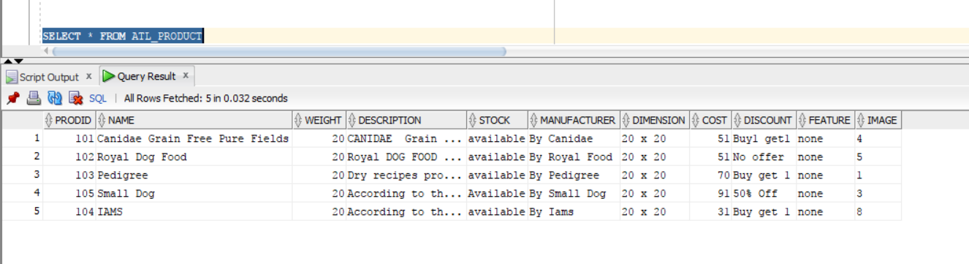

**ATL_CUST_ADD**

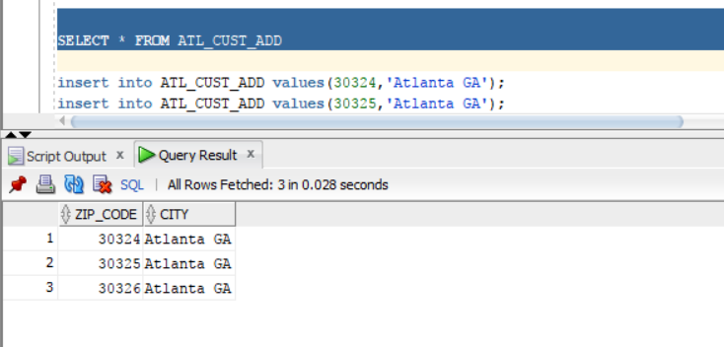

**ATL_CUSTOMER**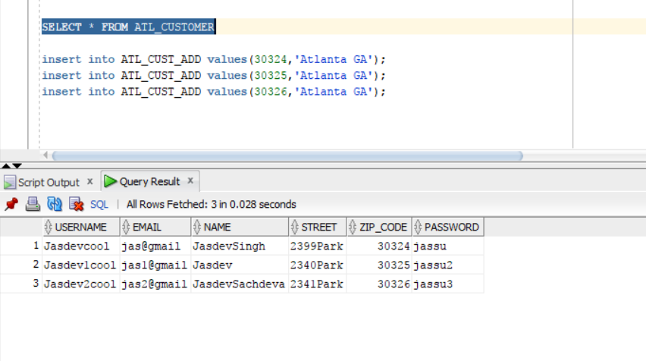

**ATL_VENDOR**

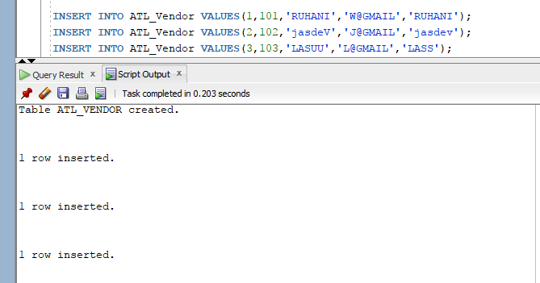

**ATL_CUST_ORDER**

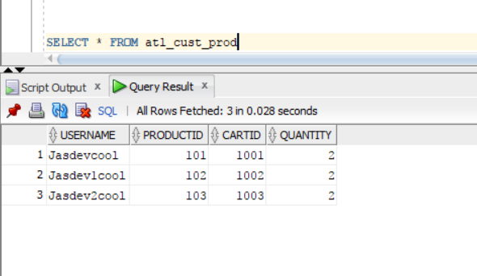

**ATL_ORDER_DETAILS**

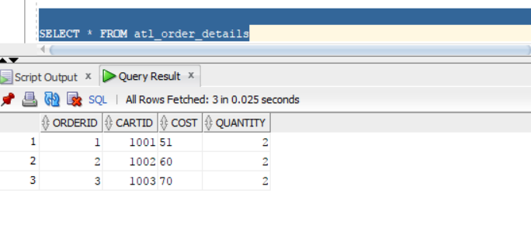

**ATL_ORDER**

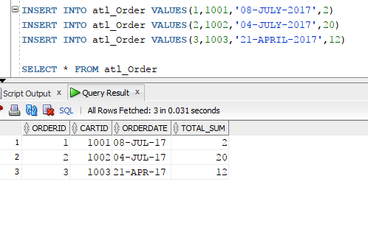

**ATL_CARD**

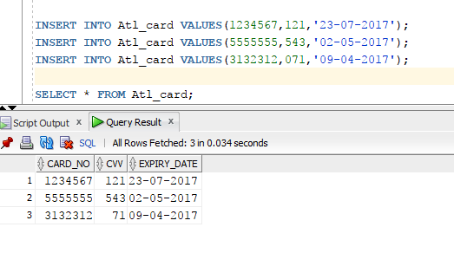

**ATL_PAYMENT_ADDRESS**

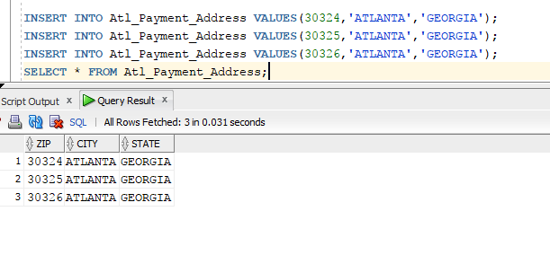

**ATL_PAYMENT :**

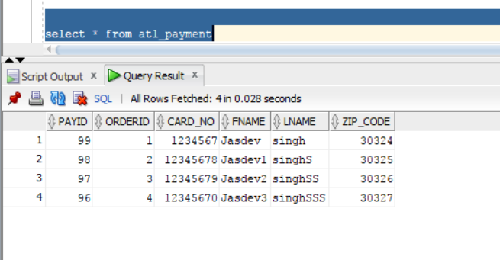

**ATL_CUST_PHONE :**

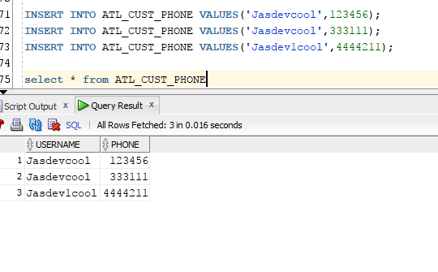

**DROP TABLES :**

DROP TABLE ATL_CUST_ADD;

DROP TABLE ATL_CUSTOMER;

DROP TABLE ATL_CUSTOMER;

DROP TABLE ATL_PRODUCT;

DROP TABLE ATL_CART;

DROP TABLE ATL_VENDOR;

DROP TABLE ATL_ORDER;

DROP TABLE ATL_CARD;

DROP TABLE ATL_PAYMENT;

DROP TABLE ATL_ PAYMENT_ADDRESS;

DROP TABLE ATL_CUST_PROD;

DROP TABLE ATL_ORDER_DETAILS;

DROP TABLE ATL_ORDERCUSTOMER;

**WEB PAGES :**

1. **Front Page:-**

This page shows what the customer first see when he/she hits the PetATL shopping cart website URL.****

1. **Signup Form :-**

This page allows new user to create account and puts entries into the database.

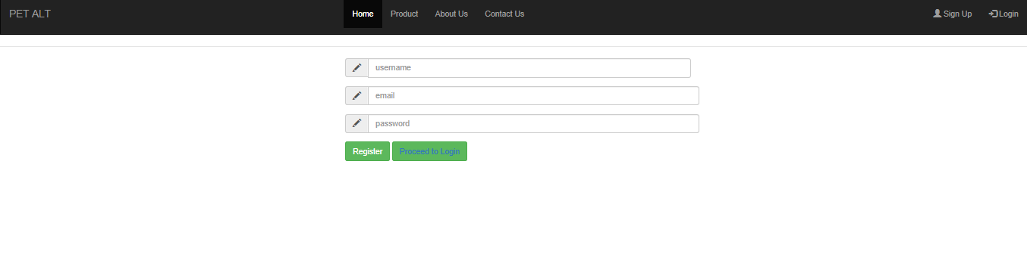

1. **Login Form :-**

Let’s the existing user to access the already created account.

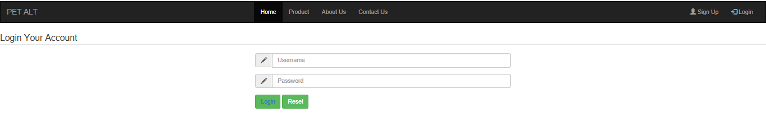

1. **List Of Products :-**

This Page shows the list of products which are available with the PetATL.

First, on the top it shows the navigation bar with option like Home, About Us, Contact US which are created to redirect the person to those pages.

Secondly, it contains links for Signup and Login which are used to add customers to the database by creating new Signup or to retrieve information of existing customer from database using Login option.

Thirdly, it shows what products are available with the PetATL in their stock and the page is linked to the database so it shows the details of the Product(name,price,details,manufacturer) along with customer ratings on every product.

Lastly, it contains the BUY NOW option to let user purchase the item.

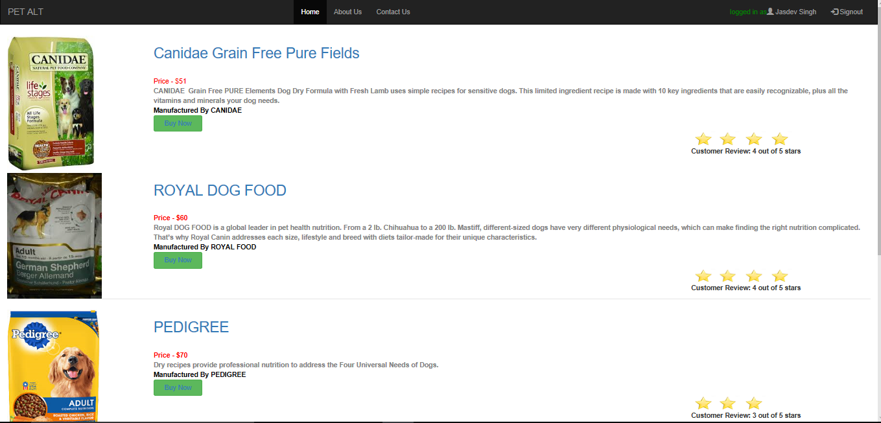

1. **Product Detail Page :-**

This page shows the details of the product available in the database like it’s price, description, Cash on Delivery option, Manufacturer’s offer, Free Delivery option.

Everything in the table is coming from ATL_PRODUCT table present in the database.

It has a ADD TO CART option which add the product to the customer cart.

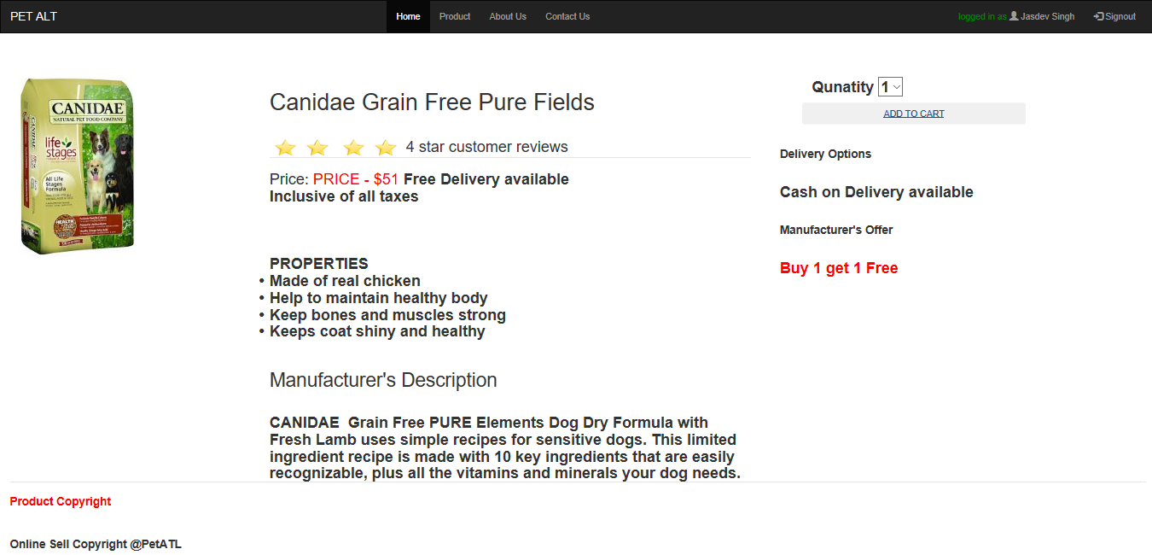

1. **Cart Page :-**

This page shows the products user will buy or willing to buy and asks for the quantity of product.

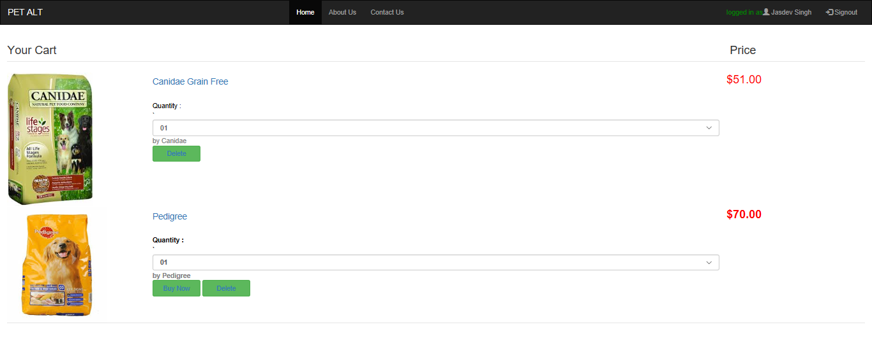

This page lets the user to Payment page via BUY NOW option.

1. **Payment Page :-**

This page let the user to enter his/her card details, shipping address, Billing address so that the payment of the order gets verified with card and also get to know the customer information to deliver the order.

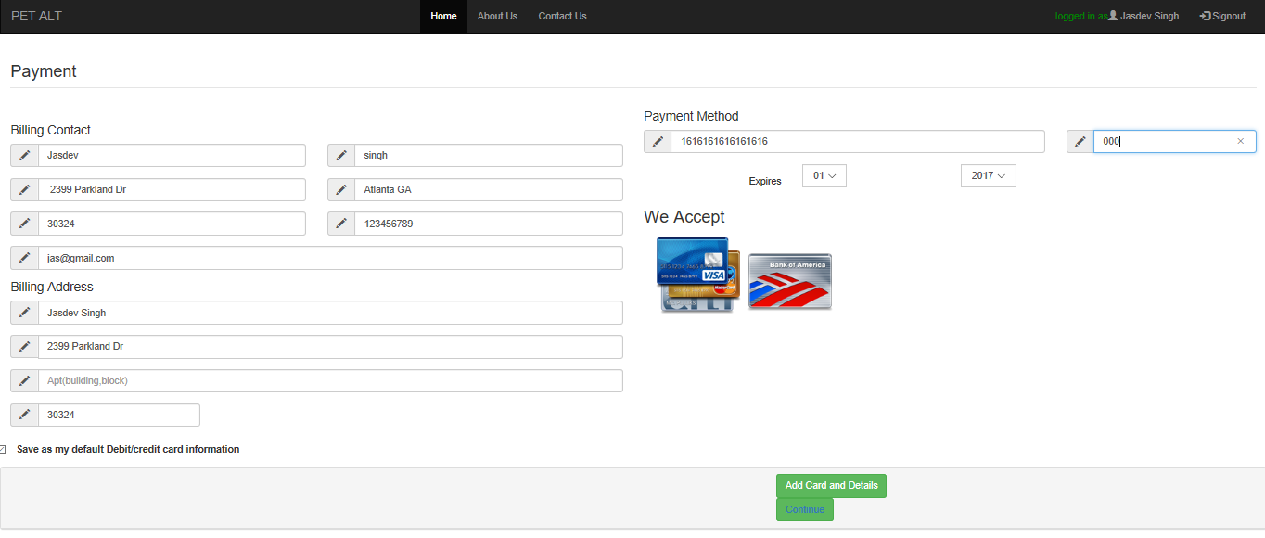

* This is just a sample query to show how the joins are working for our online store. We have joined multiple tables on different instances as and when required. We are just showing a sample output of how the payment table is connected to order table.

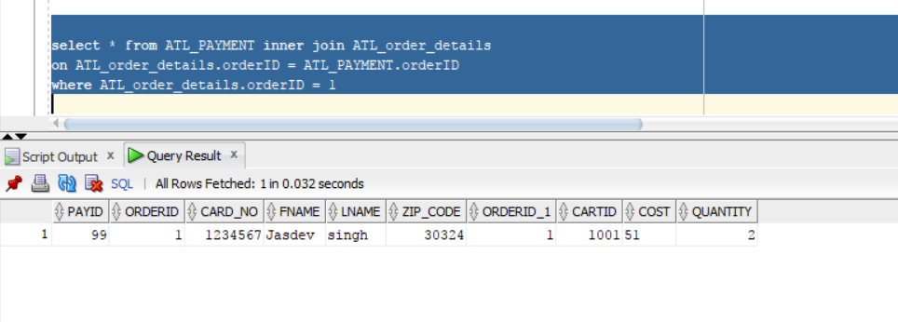

1. **Order Details and Confirmation Page :-**

This page let the user to check his/her details and asks for order confirmation and also for Offer Code.

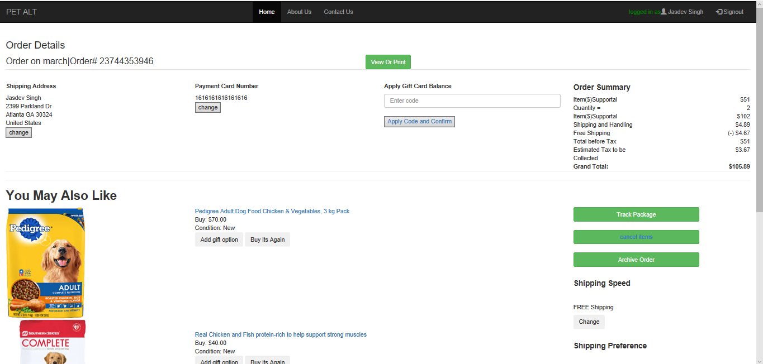

1. **Order Confirmed Page :-**

This page confirms that the order is confirmed for the login user and will be delivered to the address given by the user.

